**Scanbot: An Autonomous Robotic Teammate**

**Overview:**

As robotic technology advances, autonomous robots will be able to assist humans in a variety of tasks. In the past, robots had to be controlled by human operators, and were not capable of performing task or making decisions autonomously. Currently, robots are being developed to function autonomously, and as a result, they will be able to work alongside humans as a teammate, rather than simply used as a tool. Today you will learn about the capabilities of such a robot, named ScanBot. As you read the following information, keep in mind that the human working with Scanbot will be referred to as the “human teammate,” rather than “human operator,” due to the level of autonomy Scanbot will have.

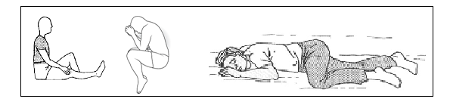**Goals and Capabilities:**

Scanbot is a robot currently being developed for use by law enforcement and the military to assist in locating immobile humans. The goal for this robot is to be capable of recognizing human forms, no matter what their position. See Image 1 for examples.

Image 1. (From left to right): Seated, fetal, and prone position

Scanbot will locate humans by recognizing independent features of the human form (torso, head, limbs, etc.) and assessing how the features are arranged. If the Scanbot determines that it has found features arranged in a way that indicates a human body, it will relay a signal to the human teammate.

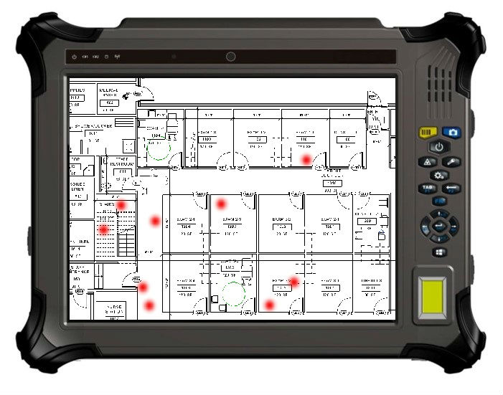The human teammate will be able to view the location of the ScanBot at all times on a remote viewing device. The signal sent from the Scanbot will appear on the viewing device until it is canceled by the human teammate (See Image 2). The human teammate cancels the signal when he or she investigates the location and either finds a human, or determines that the signal was a “false alarm,” and no human is present in that location.

Image 2. Remote viewing device displays layout of search area and signals from Scanbot

In some search scenarios, it is better to receive a “false alarm” than it is to miss something. In this case, a miss would mean not finding a person who may need help because Scanbot did not identify them as a human form. Therefore, Scanbot is programmed to be lenient in its detections, meaning that it is far more likely to make a false alarm than it is to make a miss. The number of false alarm errors made is called the false alarm rate. Scanbot has a false alarm rate of about 50%. This means that out of 10 signals from Scanbot, the human teammate will investigate the area and find a human about 5 times. The other 5 times, he or she will get to the location, and not find a human, but something vaguely resembling a human form.

The tradeoff for this high leniency is that false alarms will waste time and resources of the human teammates, and potentially put human rescuers in harm’s way. Therefore, the goal of Scanbot’s developers is to continue to make improvements to Scanbot’s programming and capabilities in order to reduce the false alarm rate in future versions.

Below is an image of what Scanbot will most likely look like when it is fully developed (Image 3), and a picture of the type of environments Scanbot will navigate (Image 4, 5, 6, and 7).

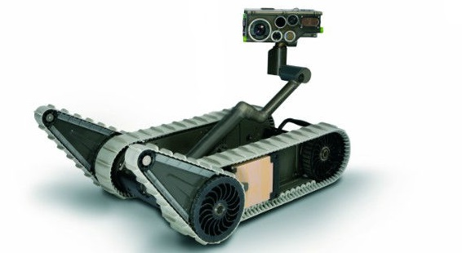Scanbot is designed to be able to navigate in uneven surfaces, make sharp turns, and look around corners before proceeding forward. The sensors sit atop an articulated (jointed) crane which allows Scanbot to raise and lower its sensors. It can raise sensors to increase their range or see over obstacles, and lower sensors to look under obstacles or fit into small spaces.

Image 3. ScanBot prototype

 Images 4 and 5.

Scanbot will correctly identify human forms 50% of the time in these types of environments. The other 50% of the time, Scanbot will erroneously identify inanimate objects as human.

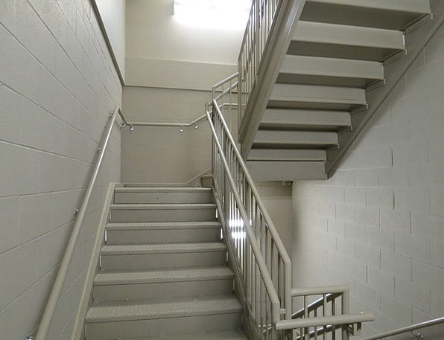

Images 6, and 7.

Scanbot will correctly identify human forms 50% of the time in these types of environments. The other 50% of the time, Scanbot will erroneously identify inanimate objects as human.